Glen Allan School Council Meeting – Virtual Platform
January 21, 2021
6:30 - 8:00 p.m.
In Attendance:
Irene Hamm, Ryan Fukala, Jenn Campbell, Jessica Winship, Erin Barrett, Judy Anderson, Dustine Vicic, Don Irwin, Stacey Robinson, Mandy
Regrets: Sheila Campbell

- The general meeting was called to order at 6:30 pm by Chair, Jessica W.

- Welcome and Introductions
Jessica W. welcomed everyone to the meeting.

- EIPS Trustee Report – Don Irwin
- In school education resumed as of January 11.
- The results review was completed with all schools in November.
- The EIPS board approved an operating budget for 2021-2022 in December of $201 million using $4.72 million of our operating reserve. The provincial budget is expected late in February and we will know more about our funding at that time.
- Value scoping exercise was conducted between September and November on the replacement of Sherwood Heights Junior high.
- EIPS is also looking at combining Campbelltown and Pine Street to apply for funding.
- 2021 is election year for school board and municipal Council’s in Alberta. Nominations opened January 4 and close September 20. The election is on Monday, October 18. For more information, see the website and obtain a copy of the candidate manual.
- In December we approved an honors program for grades eight and nine at Ardrossan Junior Senior, Sherwood Heights, and Haythorne. We used the 1400 responses from parents to plan the program.
- Due to COVID-19 and school interruptions we will not be doing PAT testing at grade 6 and nine this year.
- Returning student registration opens February 1 for 2021-2022. See details in your school newsletter or on the EIPS website. (www.eips.ca).
- The next public school board meeting is Thursday, January 21 at 10 AM and the agenda for that is online starting noon on Monday, January 18.
- Questions comments please bring these up at the meeting or text or email me at 587-986-3900 or don.irwin@eips.ca.

- Approval of November 19, 2020 Minutes
Motion: Jenn C. made motion to approve the November 19, 2020 minutes as is. Erin B. seconded. Motion carried.

- Principal’s Report – Judy Anderson
- Fee Consultation (AP 505)– Survey for input from parents School Fee Consultation

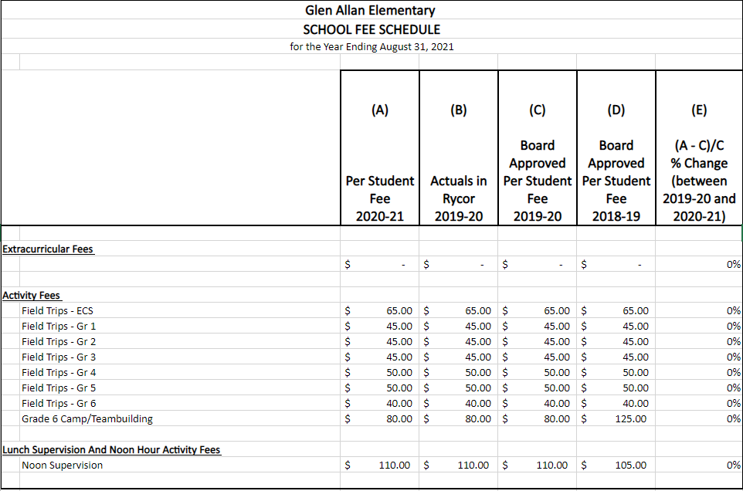

- January Wish List GLN Funding Requests –
- Library Request: High interest and newer nonfiction books that will support classroom curriculum $1500
- Library furniture including the purchase of 4 matching leather chairs to replace older cloth ones and possibly new shelves to replace magazine racks $1500
- Purple Leveled Literacy Intervention Kit – Division 2 Reading Levels R-W $4900
- Home Reading Books – $1000
- Equals Math Kit – pre-readiness math skills (attending, cause and effect, etc.), fundamental math skills (numbers and operations, measurement, and estimation), and higher order math skills (data analysis, probability, spatial sense, geometry, algebra, and problem Solving) EAs have been trained to use this math kit but we do not have it. $2400
- Staff Pink Shirt order – 38 X $12 = $456
- Total: $11 756
- Returning Student Registration – Opens Friday, February 1-28. Parents will be emailed a link to complete the registration. A form must be completed for each student in your family. It is the same process as last year and is critical that everyone does it! This is the window of opportunity to request to attend a non-designated school for the coming year. Acceptance is based on available space.
- Kindergarten Registration – Opens Friday, February 1 – For the 2021-22 school year. Your child must turn five years old on or before Dec. 31, 2021.

- Vice Principal’s Report - Dustine Vicic
- FNMI activities postponed due to COVID-19 restrictions
- February 2 Parent Series -link to join on the Glen Allan website

- Teacher Report – Stacey Robinson
- January 26 - Grade 5 Altview presentation – Themes of kindness, acceptance, and bullying prevention
- January 29 – Professional Learning Day
- February 4/5 – Teachers Convention
- February 10/11 – Parent teacher interviews – virtually
- Spirit Days – PJ Day, Secret Theme Day, Flock Day, Hat Day, Color Day
- Math Project
- February 24 - Pink shirt day

- School Council Updates
Programs Vice-Chair Updates
  - Action: Spirit Wear discussion deferred to February meeting
  - Staff Appreciation suggestions in lieu of regular staff appreciation lunch:
    - Individual charcuterie boards. Group supportive of this idea. Action: Jenn volunteered to research cost and bring back for discussion at the February meeting.
    - Suggestion to fund the pink t-shirts for Glen Allan Staff out of the Teacher Appreciation budget line in GASC Operating Budget as staff recognition.

Motion: Ryan F. made motion to approve the purchase of the Pink t-shirts
for staff. Jenn C. seconded. Motion carried.

Fund Development Committee Chair Updates – Jenn Campbell
  - Art Cards update: $3000 revenue, $899 expenses, $500 new printer, $1641.79 profit
  - Virtual Book Fair scheduled for the end of February

Budget Vice-Chair Updates – Erin Barrett
    - Erin presented the current GASC financial report.
    - Disbursements/funding for 2021-2022 discussion. Action: tabled to February meeting for further discussion of budget implications to ensure reasonable financial standing for next year and vote.
  - Financial procedures update: seeking input from council members regarding
previous documented financial procedures. Action: Will bring proposed documents to a future meeting for discussion/vote.

Chair Updates - Jessica Winship
  - Update 20/21 Reporting: Society Annual Return for 19/20 submitted in December
  - Council Member Intentions for 2021/22, please start thinking about. Action: For discussion at February meeting.
    - Secretary vacancy for 2021/22

- Parent Feedback/Suggestions
- No items.

Meeting adjourned at 8:03 PM. Next meeting February 18, 2021 via virtual platform.

